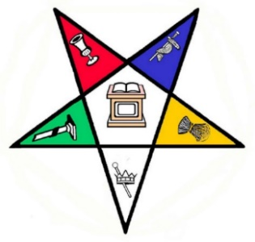

Warwick Chapter No. 43, Order of the Eastern Star
Application for the
Daphene D. Watson Scholarship

Applicant’s Full Name______________________________________________________

Current Address:__________________________________________________________
(street address, apartment Number, Post Office Box, as appropriate)

________________________________________________________________
(City, State, and Zip Code)

Email Address:___________________________________________________________________

Phone Number:__________________________________________________________________

Parent’s Name:___________________________________________________________________

Current Address:__________________________________________________________________
(street address, apartment number, Post Office Bo, as appropriate)

__________________________________________________________________
(City, State, and Zip Code)

Applicant’s Date of Birth:___________________________________________________________

School Currently attending:_________________________________________________________
(High School, College, Professional School/Trade School)

Current Grade Level:_______________________

List Colleges/Schools where applied and/or have been accepted/attending:

________________________________________________________________________________

________________________________________________________________________________

Planned Major(s):__________________________________________________________________

Vocational Goals Statement(2-3 Sentences):_____________________________________________

_________________________________________________________________________________

_________________________________________________________________________________

_________________________________________________________________________________

GPA(as of last semester):_________________________
(If in college or trade school must be GPA from that institution. If in high school must be GPA from applicant’s high school)

Have you ever been placed on probation or dismissed from any school? ____yes ____no

If yes, explain fully on a separate sheet of paper and attach it to the application.

Warwick Chapter No. 43, Order of the Eastern Star Affiliation: Person listed must a in good standing currently or at the time of his/her death of Warwick Chapter No. 43, Colonial Chapter No. 40, or Pocahontas Chapter No. 103, OES. Please list the name of the Warwick Chapter No. 43,Colonial Chapter No. 40, or Pocahontas Chapter No. 103, OES member you are related to and how you are related. If self, write self and your name. If no direct affiliation with Warwick Chapter No. 43, Colonial Chapter No. 40, or Pocahontas Chapter No. 103, you must be a member of one of the following local Masonic Youth Organizations: Hampton Assembly No. 2, International Order of the Rainbow for Girls, Tidewater DeMolay, or Yorktown Bethel 39 or Hampton Bethel 13 Jobs Daughters International. (Please see Eligibility Requirements on Scholarship Guidelines sheet.)

__________________________________________________________________________________

I certify that the information supplied on this application is, to the best of my knowledge, true and accurate. All decisions of the Scholarship Committee are final.

Applicant’s Signature:_______________________________________________________________

Date of Application:_________________________________________________________________

(Updated 11/25/25)

